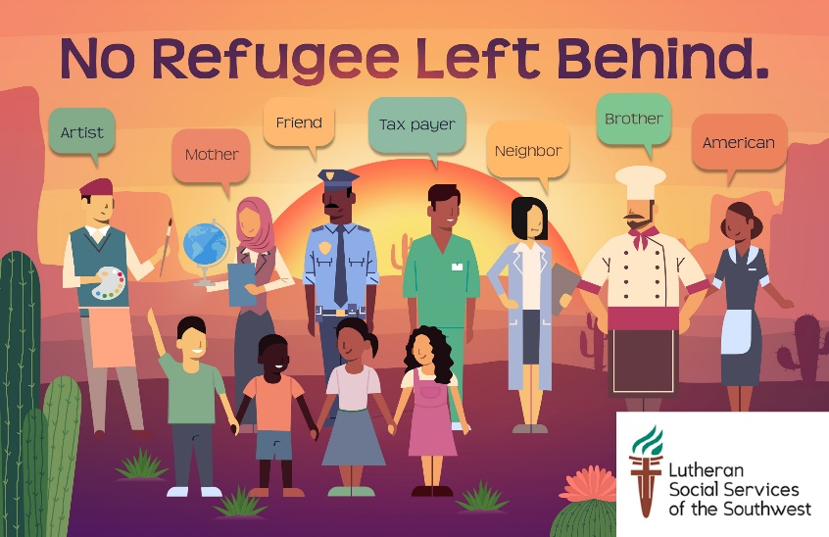

POSTCARD WRITING PARTY
We are facing the world’s worst refugee crisis in recorded history with over 25 million refugees, over half of whom are children. In response, last year the Administration agreed to welcome 45,000 refugees to the U.S. But only 22,491 refugees were accepted in, leaving 22,491 refugees behind.
Similarly in Arizona, 2,410 refugees were projected to arrive. But only 1,392 refugees made it here, leaving 1,018 refugees behind.
In 2019 the Administration has agreed to admit 30,000 refugees. Don’t let them default on their commitment again!

HELP US SEND A TOTAL OF 1,018 POSTCARDS TO ARIZONA MEMBERS OF CONGRESS AND TELL THEM WHY REFUGEES ARE IMPORTANT TO OUR COMMUNITIES. ONE POSTCARD FOR EVERY REFUGEE WHO NEVER MADE IT TO ARIZONA LAST YEAR.
TELL THEM TO URGE THE PRESIDENT TO HONOR HIS COMMITMENT AND TRULY WELCOME 30,000 REFUGEES.
We have everything you need in our toolkit to make your voice heard!

YOU CAN DO THIS IN 5 STEPS:
- Contact us and we’ll mail you the toolkit. (The toolkit contains a fact sheet, message starters, and postcards.) You can also choose to print the toolkit.
- Create an event, or use one already organized where lots of people can sign the postcards. You can do this at church events, town meetings, club meetings, family dinners, girls’ night out…etc. You can even organize a virtual party, where people send you their message by email, text or chat - then copy their message and address on the postcards.
- On the day of the event, let the people participating quickly read the fact sheet so they know what they are standing up for. Each individual will write a postcard explaining why they believe we should welcome more refugees into the U.S./why refugees are important to our communities.
- Display the message starters on big poster boards, so they can get ideas of what to write to their congressional representative. (If you don’t know who your congressional representatives are, we can tell you that).
- Collect the postcards from your guests, and send them our way! You can mail them to us, drop them off at our Phoenix or Tucson office, or we can arrange to come and collect them from you.

Between April and May, we’ll deliver in person the 1,018 hand-written postcards to all the congressional representatives. You can even join us and help on the day of delivery!

OUR CONTACT INFO:

PHOENIX OFFICE
2502 E. University Drive
Suite 125
Phoenix, AZ 85034

ADVOCACY VOLUNTEER
Charlotte Shurtz
charlotte.shurtz@gmail.com
480-322-7567

