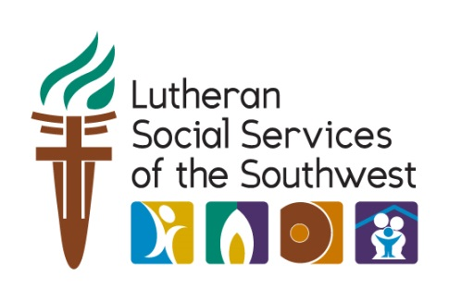
On January 27, 2017 President Donald Trump signed an executive order which turns our backs on Syrian refugees and refugees from around the world at the very time when they are most in need of safety.
The resettlement program was started by faith communities in the United States. As people of faith, our call is to welcome the stranger and care for God’s most vulnerable people – the widow, the orphan, and the refugee.
Our National Values and Longstanding Legacy of Welcome is Being Threatened
By halting refugee resettlement for 120 days, refugees are pulled off planes; families who are anticipating their loved ones will be devastated; and the infrastructure that supports refugees will be stuck in limbo.
By reducing refugee admissions from 110,000 to 50,000, President Trump is going back on America’s promise to refugees and abdicating America’s leadership role on human rights and refugee protection.
By stopping resettlement of Syrian refugees and narrowly preferencing religious minorities, this announcement is tantamount to the Muslim ban President Trump threatened during his campaign, and is a clear case of religious discrimination.
Please sign up to become a Refugee Advocate on our website. We will send you email alerts with our most current news and information about how you can advocate for refugees in your community.
Thank you for standing with those who are persecuted.

